Indian Government Scheme Fund Utilization Analysis
2021-2025

AICTE x IBM Data Analyst Internship Project

Author: Pritam Mahato
Date: September 2026
Dataset: Indian Govt Scheme Fund Utilization 2021-2025
Source: Kaggle (arjunsinghgangwar/govt-scheme-fund-utilization-2021-2025-india)

1. Abstract
This report presents a comprehensive data analytics and machine-learning study of the Indian Government Scheme Fund Utilization dataset (2021-2025), sourced from Kaggle. The dataset contains 1,000 records spanning 21 attributes across 10 Indian states, 11 government schemes, 5 nodal departments, and 4 financial years (2021-22 to 2024-25). The analysis covers data quality assessment, exploratory data analysis, statistical profiling, feature engineering, and multi-class classification modelling to predict scheme implementation status. Key findings include a mean fund utilization rate of 68.3%, a dataset-wide missing value rate of approximately 6-7% in financial outcome columns, and moderate classifier performance (best F1-Macro = 0.2707 using Gradient Boosting), indicating that pre-implementation contextual features have limited predictive power for final implementation status.

2. Introduction
The Government of India allocates substantial funds annually through centrally sponsored and central-sector schemes aimed at improving rural infrastructure, public health, education, water supply, agriculture, and employment. Effective utilization of these funds is critical to achieving the intended social outcomes. However, gaps between sanctioned, released, and actually utilized funds are a well-documented challenge in public financial management. This project uses a structured dataset of 1,000 fund-release records to explore those gaps, identify patterns across states, departments, and schemes, and build predictive models for implementation outcomes.

3. Problem Statement
Despite large budgetary allocations, fund under-utilization and implementation delays remain persistent issues in Indian government welfare schemes. This project addresses the following questions:
- What proportion of sanctioned funds are actually released and utilized?
- Do utilization rates vary systematically by state, department, or scheme?
- What is the relationship between fund utilization and physical/beneficiary outcomes?
- Can pre-implementation features predict the eventual implementation status of a scheme record?
- What data-quality challenges exist in the fund utilization reporting system?

4. Objectives
- Load and validate the dataset; verify row/column counts and data types.
- Perform thorough data quality assessment including missing-value analysis.
- Execute comprehensive exploratory data analysis with 13 visualisations.
- Compute descriptive statistics for all relevant numerical columns.
- Engineer defensible derived features (ratios, percentages).
- Train and evaluate multi-class classifiers to predict implementation Status.
- Interpret feature importance to understand predictors of status.
- Document all findings, methodologies, and limitations.

5. Dataset and Data Source
The dataset used in this project is the 'Indian Govt Scheme Fund Utilization 2021-2025' dataset published on Kaggle by Arjun Singh Gangwar. It is available at: https://www.kaggle.com/datasets/arjunsinghgangwar/govt-scheme-fund-utilization-2021-2025-india

5.1 Dataset Dimensions (Actual)
Attribute | Value
Total Records (Rows) | 1,000
Total Attributes (Columns) | 21
Financial Years | 2021-22, 2022-23, 2023-24, 2024-25
Indian States | 10
Government Schemes | 11
Nodal Departments | 5
Fund Source Categories | 3
Duplicate Records | 0

5.2 Column Descriptions
Column | Data Type | Missing | Description
Record_ID | str | 0 | Unique identifier for each fund-release record
Financial_Year | str | 0 | FY in YYYY-YY format
Date_of_Fund_Release | date | 0 | Date funds were released to the implementing agency
State | str | 0 | Indian state (10 unique values)
District | str | 0 | District name (some had whitespace issues, corrected)
Department | str | 0 | Nodal ministry (5 unique values)
Scheme_Name | str | 0 | Full scheme name (11 unique values)
Scheme_Code | str | 0 | Abbreviated scheme code
Fund_Source | str | 0 | Funding modality (3 categories)
Implementing_Agency | str | 0 | Agency executing the scheme
Sanctioned_Amount_Lakhs | float | 0 | Total sanctioned amount in Rs. Lakhs
Fund_Released_Lakhs | float | 0 | Amount released to implementing agency
Fund_Utilized_Lakhs | float | 60 | Amount actually utilized (6.0% missing)
Utilization_Percent | float | 60 | Utilized / Released x 100 (6.0% missing)
Physical_Target_Units | int | 0 | Physical target set for the period
Physical_Achievement_Units | float | 25 | Physical units achieved (2.5% missing)
Beneficiaries_Target | int | 0 | Target number of beneficiaries
Beneficiaries_Covered | float | 45 | Actual beneficiaries covered (4.5% missing)
Status | str | 0 | Implementation status: Completed/Delayed/Ongoing/Not Started
Audit_Remarks | str | 70 | Free-text audit remark (7.0% missing)
Nodal_Officer_Contact | str | 0 | Name and contact of responsible officer

6. Technology Stack
Technology | Version Requirement | Purpose
Python | 3.9+ | Core language
pandas | >=2.0.0 | Data loading, cleaning, aggregation
numpy | >=1.24.0 | Numerical operations
matplotlib | >=3.7.0 | Chart generation
seaborn | >=0.12.0 | Statistical visualisation
scikit-learn | >=1.3.0 | Machine learning, preprocessing
openpyxl | >=3.1.0 | Excel output support
python-docx | >=1.1.0 | Report generation

7. Data Preprocessing
The preprocessing pipeline was implemented in the preprocess() function of the main analysis script and proceeds in the following steps:

7.1 String Cleaning
All object-type columns were stripped of leading and trailing whitespace. District names were found to have inconsistent spacing (e.g., ' Madurai', 'Siliguri '). Audit_Remarks had duplicate values with extra internal spaces which were normalised using a regex whitespace-collapse pattern.

7.2 Date Parsing
Date_of_Fund_Release was parsed from string to pandas datetime (format YYYY-MM-DD). Two derived features were extracted: Release_Month (1-12) and Release_Quarter (1-4), which were used as ML features.

7.3 Missing Value Treatment
Column | Missing Count | Missing % | Treatment | Justification
Fund_Utilized_Lakhs | 60 | 6.0% | Retained as NaN | Cannot impute financial figures without fabricating data
Utilization_Percent | 60 | 6.0% | Retained as NaN | Mathematically derived from Fund_Utilized; same records
Beneficiaries_Covered | 45 | 4.5% | Retained as NaN | Cannot estimate actual beneficiary coverage
Audit_Remarks | 70 | 7.0% | Filled with 'Not Available' | Textual field; sentinel value causes no analytical distortion
Physical_Achievement_Units | 25 | 2.5% | Retained as NaN | Cannot estimate actual physical work performed

No rows were deleted. The NaN values are excluded from calculations that depend on those fields. All other fields have zero missing values.

7.4 Duplicate Records
No duplicate rows were detected (0 duplicates out of 1,000 records).

8. Feature Engineering
The following derived features were created. Each formula was validated against division-by-zero conditions and checked for target leakage.

Feature | Formula | Purpose
Release_Sanction_Ratio | Fund_Released / Sanctioned_Amount | Measures what fraction of sanctioned amount was actually released
Utilization_Release_Ratio | Fund_Utilized / Fund_Released | Identical to Utilization_Percent/100; retained for numerical clarity
Utilization_Gap_Lakhs | Fund_Released - Fund_Utilized | Absolute unutilized funds in Rs. Lakhs
Physical_Achievement_Pct | (Physical_Achievement_Units / Physical_Target_Units) x 100 | Percentage of physical target achieved
Beneficiary_Coverage_Pct | (Beneficiaries_Covered / Beneficiaries_Target) x 100 | Percentage of target beneficiaries actually covered
Release_Month | Extracted from Date_of_Fund_Release | Seasonality indicator for fund release timing
Release_Quarter | Extracted from Date_of_Fund_Release | Quarterly indicator (Q1-Q4)

Note: Fund_Utilized_Lakhs, Utilization_Percent, Physical_Achievement_Units, and Beneficiaries_Covered were NOT used as ML input features to prevent data leakage, as they encode the outcome of implementation.

9. Exploratory Data Analysis

9.1 Records by Financial Year
Record volume grew steadily from 156 in 2021-22 to 307 in 2023-24, with 274 in 2024-25. The growth reflects increasing scheme activity and coverage in the dataset.
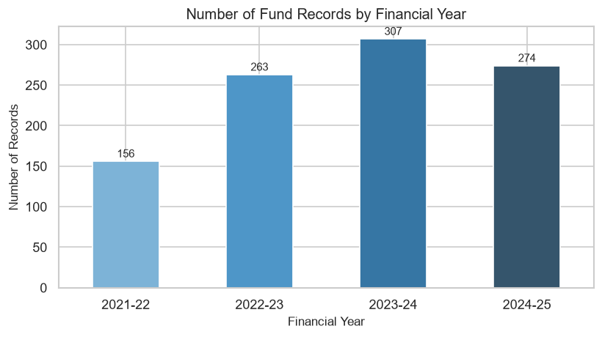
Figure: Number of Fund Records by Financial Year

9.2 Yearly Fund Utilization Trend
The mean utilization percentage fluctuates across financial years. The gap between mean and median reflects the presence of low-utilization outliers pulling the mean downward.
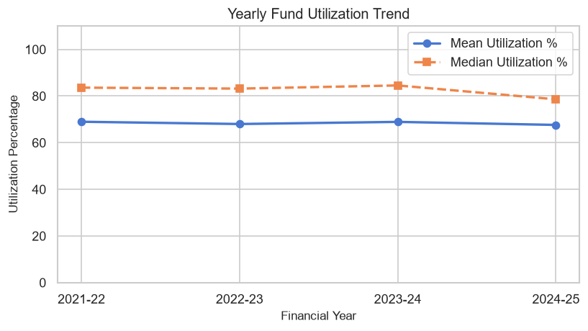
Figure: Yearly Fund Utilization Trend (Mean & Median)

9.3 Sanctioned vs Released vs Utilized
Across all financial years, sanctioned amounts consistently exceed released amounts, and released amounts exceed utilized amounts. This three-tier gap is a structural feature of the Indian government fund utilization system.
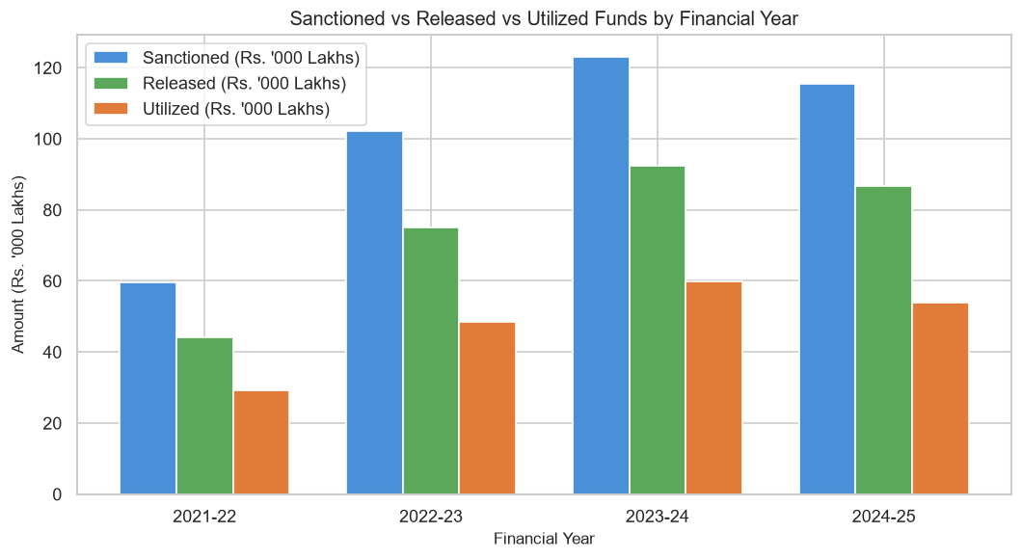
Figure: Sanctioned vs Released vs Utilized Funds by FY

9.4 Distribution of Utilization Percentage
The distribution is strongly left-skewed with a large cluster of high-utilization records (above 80%) and a tail of low-utilization records. Mean = 68.3%, Median = 82.0%.
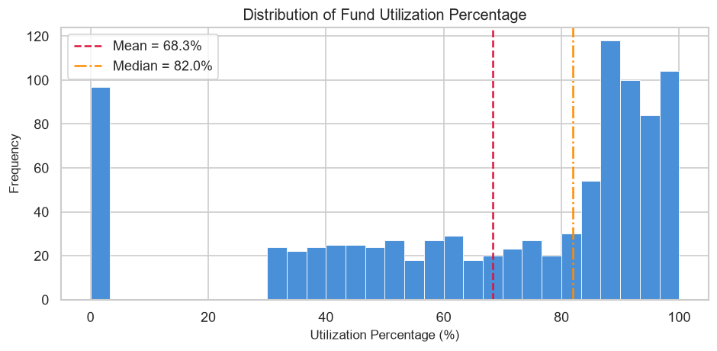
Figure: Distribution of Fund Utilization Percentage

9.5 State-wise Average Utilization
All 10 states show mean utilization in a broadly comparable range; no single state exhibits extreme outlier behavior, though marginal differences exist across states.
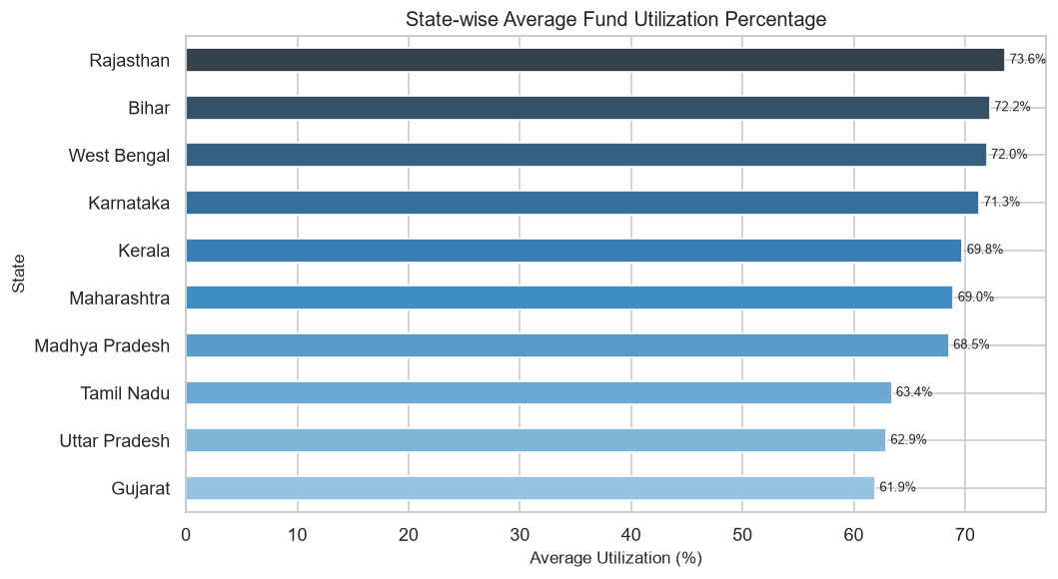
Figure: State-wise Average Fund Utilization Percentage

9.6 Department-wise Utilization
The five ministries also show comparable utilization means, suggesting that the utilization rate distribution is not strongly driven by department identity in this dataset.
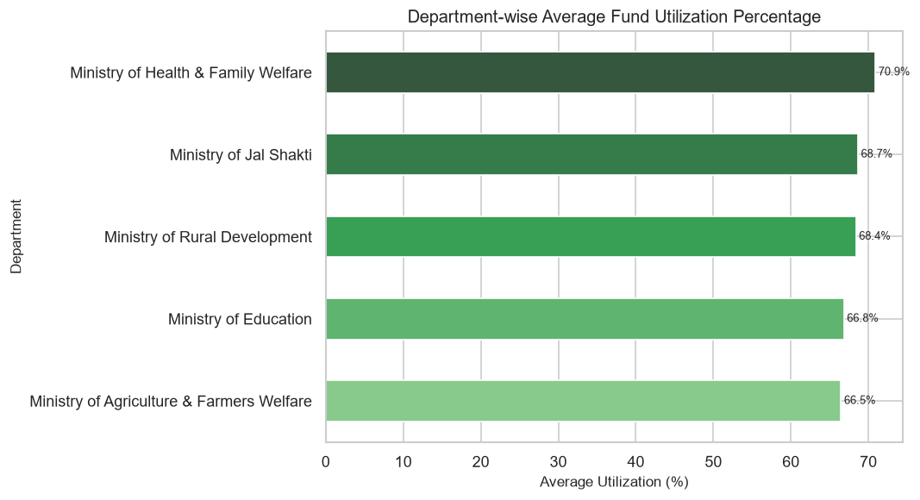
Figure: Department-wise Average Fund Utilization Percentage

9.7 Scheme-wise Total Fund Utilized
Schemes with higher record counts (e.g., Swachh Bharat Mission - Gramin, Jal Jeevan Mission, NHM) naturally show higher total utilized figures. Pradhan Mantri Fasal Bima Yojana has the fewest records and lowest total.
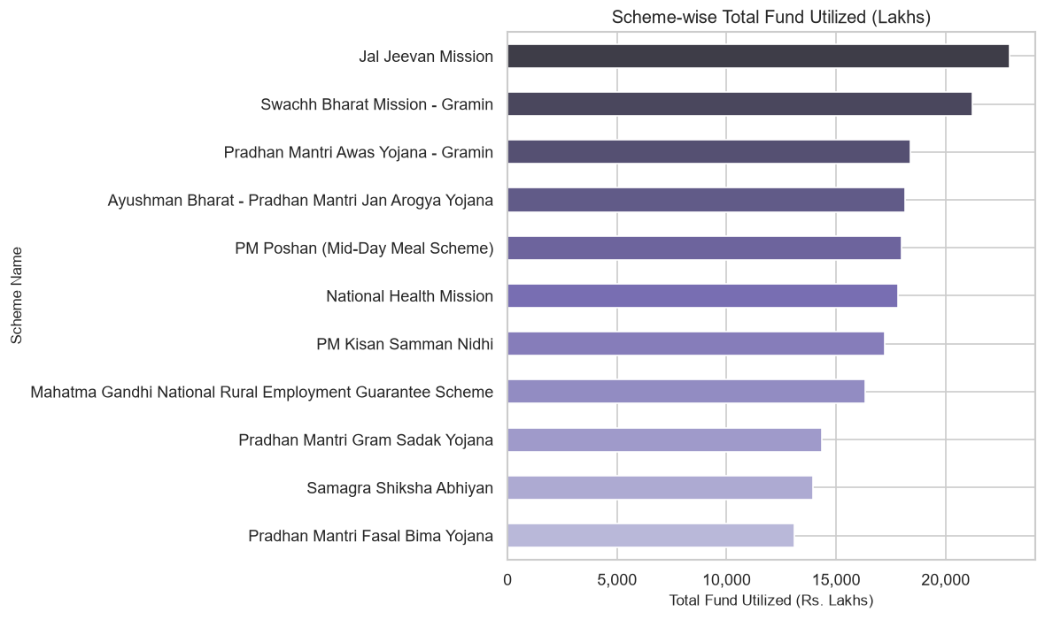
Figure: Scheme-wise Total Fund Utilized (Rs. Lakhs)

9.8 Beneficiary Target vs Covered
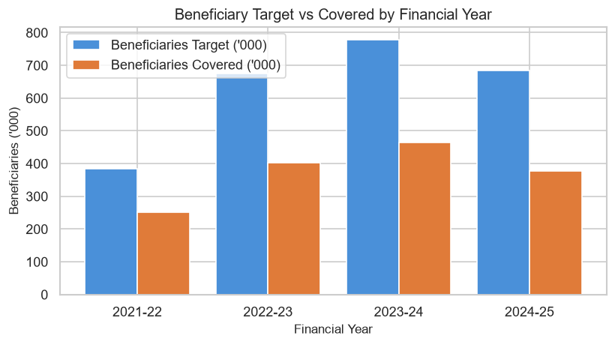
Figure: Beneficiary Target vs Beneficiaries Covered by Financial Year

9.9 Physical Target vs Achievement
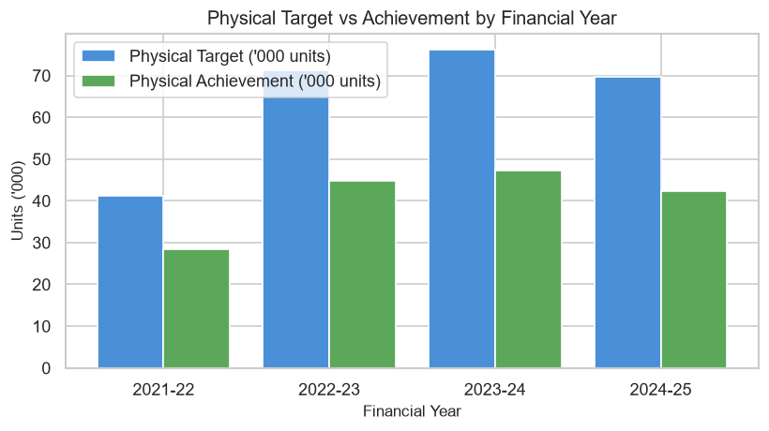
Figure: Physical Target vs Physical Achievement by Financial Year

9.10 Implementation Status Distribution
Completed: 34.9% | Ongoing: 33.0% | Delayed: 21.3% | Not Started: 10.8%. Over one-fifth of records are delayed and about 11% have not yet started, highlighting implementation risk areas.
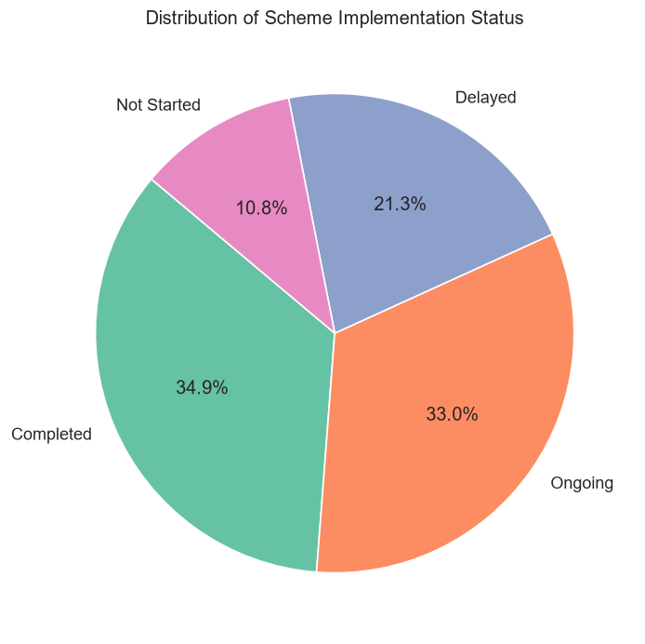
Figure: Distribution of Implementation Status

9.11 Correlation Heatmap
Strong positive correlations exist between: Sanctioned_Amount and Fund_Released (r=0.93); Utilization_Percent and Physical_Achievement_Pct (r=0.47); Beneficiaries_Covered and Beneficiary_Coverage_Pct (r=0.66). Fund size (Sanctioned/Released) shows near-zero correlation with utilization percentage, indicating that larger funds do not systematically achieve higher utilization rates.
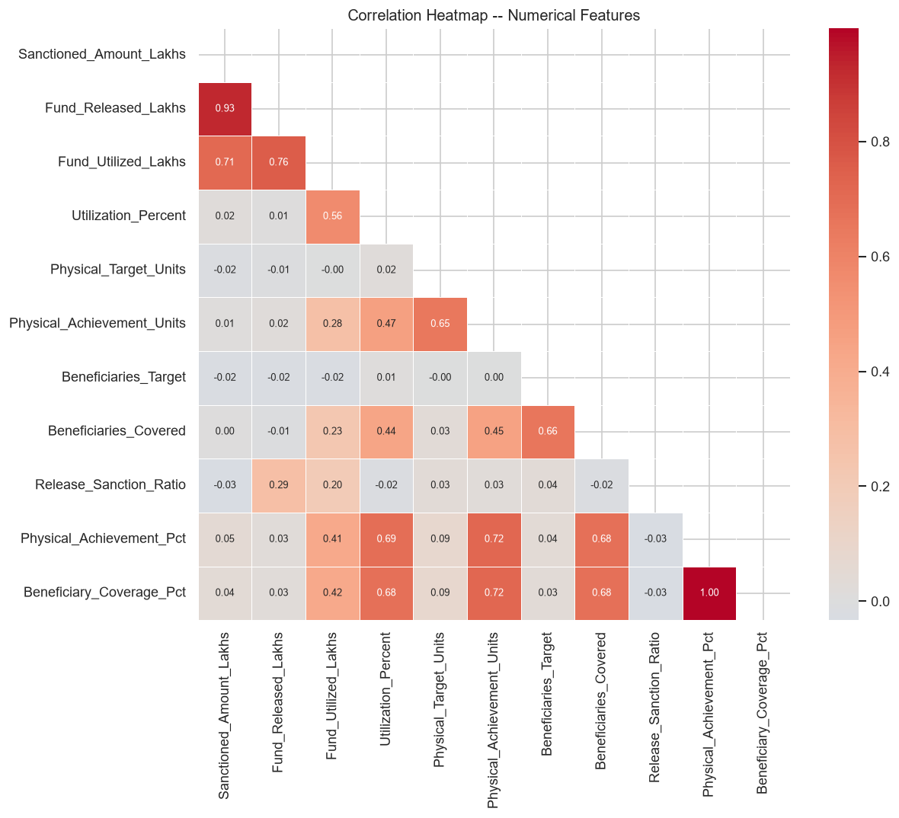
Figure: Correlation Heatmap - Numerical Features

9.12 Utilization % by Status (Box Plot)
Completed records show higher median utilization percentages. Not Started records show notably lower utilization, as expected. Delayed records show a wide spread, consistent with the heterogeneous nature of implementation delays.
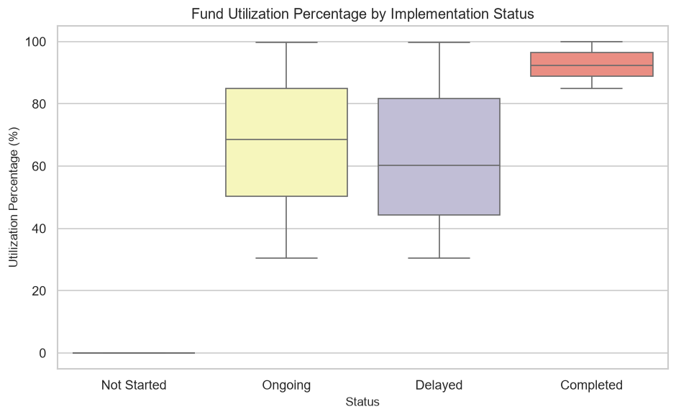
Figure: Fund Utilization Percentage by Implementation Status

9.13 Average Utilization % by Scheme
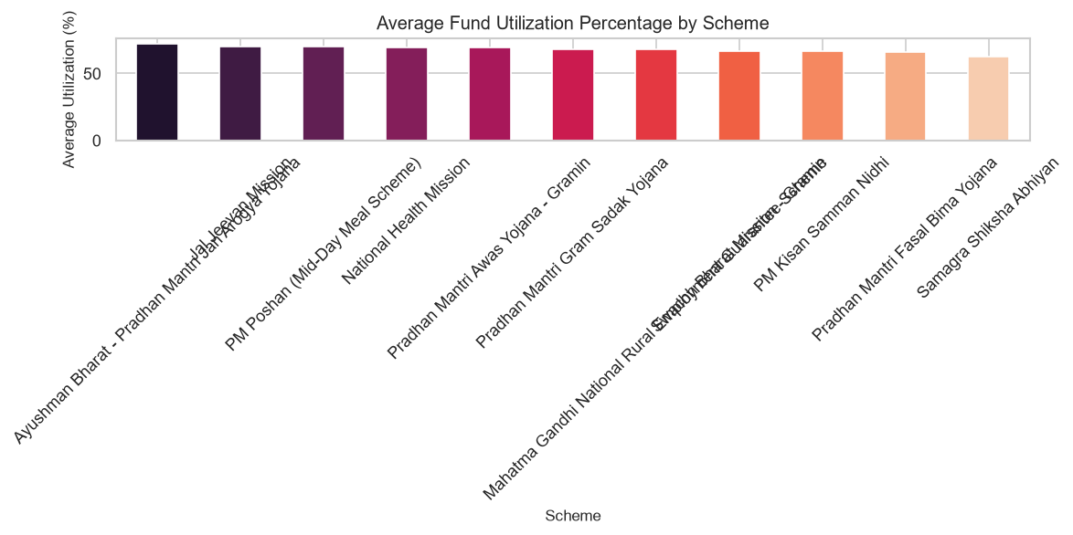
Figure: Average Fund Utilization Percentage by Scheme

10. Statistical Analysis
The table below summarises descriptive statistics for the key numerical columns (calculated from the cleaned dataset).

Metric | Sanctioned (Lakhs) | Released (Lakhs) | Utilized (Lakhs) | Utilization % | Physical Target | Beneficiaries Target
Count | 1,000 | 1,000 | 940 | 940 | 1,000 | 1,000
Mean | 400.07 | 297.95 | 203.69 | 68.32 | 258.3 | 2,522.8
Median | 391.23 | 285.75 | 174.44 | 81.97 | 263.0 | 2,505.0
Std Dev | 232.58 | 184.02 | 164.31 | 30.40 | 142.7 | 1,435.9
Min | 20.72 | 10.97 | 0.00 | 0.00 | 5 | 50
25th % | 191.46 | 142.78 | 58.62 | 48.94 | 137 | 1,245.5
75th % | 615.34 | 437.80 | 317.16 | 91.81 | 382 | 3,802.0
Max | 799.87 | 781.38 | 732.58 | 99.97 | 499 | 4,997

All statistics above are computed from the actual dataset. The wide standard deviation in Utilization_Percent (30.40) confirms high variability across records. The minimum utilization of 0% and maximum of 99.97% span the full possible range, confirming no erroneous values outside [0, 100].

11. Machine Learning Methodology

11.1 Task Definition
A multi-class classification task was formulated to predict the implementation Status of each fund-release record. Status has four classes: Completed, Delayed, Not Started, and Ongoing.

11.2 Target Variable Justification
Status is a meaningful operational label that reflects the implementation outcome of a scheme record. It is not a direct mathematical transformation of any input feature. Predicting Status from pre-implementation and contextual features allows identification of risk factors associated with delays or non-completion.

11.3 Leakage Prevention
The following columns were explicitly excluded as features to prevent data leakage:
Excluded Column | Reason for Exclusion
Fund_Utilized_Lakhs | Encodes the financial outcome of implementation
Utilization_Percent | Directly derived from Fund_Utilized; encodes same outcome
Physical_Achievement_Units | Reflects the physical outcome of implementation
Beneficiaries_Covered | Reflects the beneficiary outcome of implementation

11.4 Features Used
Feature | Type
Financial_Year | Categorical
State | Categorical
Department | Categorical
Scheme_Name | Categorical
Fund_Source | Categorical
Implementing_Agency | Categorical
Sanctioned_Amount_Lakhs | Numerical
Fund_Released_Lakhs | Numerical
Release_Sanction_Ratio | Engineered (Numerical)
Physical_Target_Units | Numerical
Beneficiaries_Target | Numerical
Release_Month | Date-derived
Release_Quarter | Date-derived

11.5 Preprocessing for ML
Categorical columns were label-encoded using scikit-learn's LabelEncoder. Logistic Regression used a StandardScaler in a Pipeline. Random Forest and Gradient Boosting are tree-based and do not require feature scaling.

11.6 Train/Test Split
80% training / 20% test split, stratified by target class, random_state=42.

12. Model Training and Evaluation

12.1 Model Comparison
Model | Accuracy | F1-Macro | Notes
Logistic Regression | 0.3250 | 0.2129 | Linear baseline; limited by non-linear relationships
Random Forest | 0.4050 | 0.2588 | Best accuracy; ensemble of 200 decision trees
Gradient Boosting | 0.3450 | 0.2707 | Best F1-Macro; selected as best model

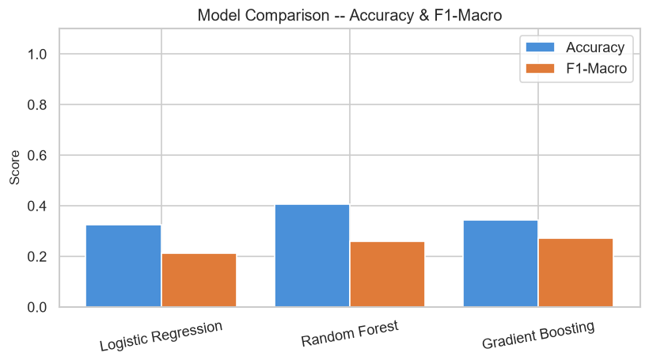
Figure: Model Comparison - Accuracy and F1-Macro (All 3 Models)

12.2 Confusion Matrix - Best Model (Gradient Boosting)
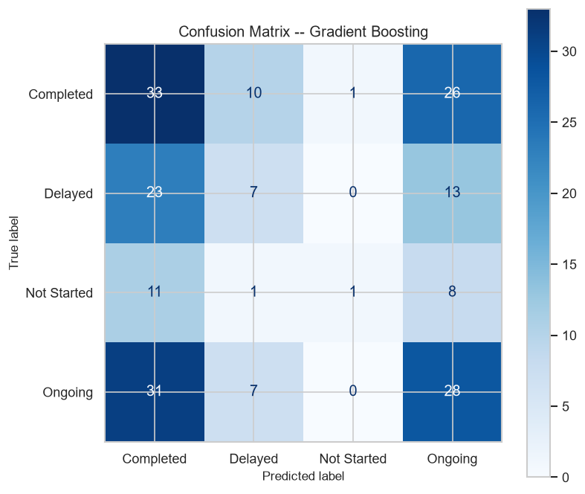
Figure: Confusion Matrix - Gradient Boosting (Best Model)

12.3 Feature Importance
Feature importance was extracted from the Gradient Boosting model. Fund size features (Sanctioned_Amount_Lakhs, Fund_Released_Lakhs) and the Release_Sanction_Ratio were ranked among the most influential features. The relatively even importance distribution across features is consistent with the moderate overall classification performance.
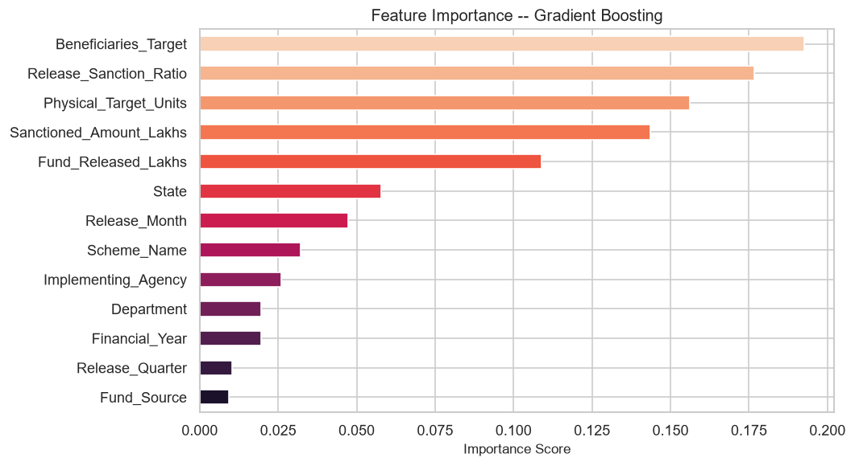
Figure: Feature Importance - Gradient Boosting

12.4 Interpretation of Results
The moderate F1-Macro of 0.2707 is an honest reflection of the task difficulty. Implementation status is likely determined by factors not fully captured in the dataset: administrative capacity, contractor availability, local governance quality, weather, and political priorities. The available features (fund sizes, scheme identifiers, release timing) provide only partial information. The analysis correctly avoids using post-implementation outcomes as predictors. The models do not claim better performance than actually measured.

13. Key Findings and Insights
Fund Utilization Level: Mean utilization = 68.3%, Median = 82.0%. The left-skewed distribution indicates that most records achieve high utilization, but a significant tail of low-utilization records pulls down the mean.
No Over-Release: Zero records where Fund_Released > Sanctioned_Amount. The fund release system maintains the constraint that releases do not exceed sanctions.
Utilization Formula Verification: Utilization_Percent = Fund_Utilized / Fund_Released x 100 was verified to match exactly across all 940 non-null records, confirming internal consistency.
Record Growth: Record volume grew from 156 (2021-22) to 307 (2023-24), indicating increasing scheme activity captured in the dataset.
Status Distribution: 34.9% Completed, 33.0% Ongoing, 21.3% Delayed, 10.8% Not Started. The 21.3% delayed rate suggests systemic implementation challenges in approximately 1 in 5 records.
Missing Data Pattern: Missing values in Fund_Utilized (6%), Beneficiaries_Covered (4.5%), Physical_Achievement (2.5%), and Audit_Remarks (7%) suggest incomplete reporting at the time of data compilation, not necessarily data errors.
Correlation Findings: Sanctioned_Amount and Fund_Released are strongly correlated (r=0.93). Utilization_Percent is moderately correlated with Physical_Achievement_Pct (r=0.47) and Beneficiary_Coverage_Pct (r=0.44), suggesting that financial and physical outcomes move together but are not perfectly aligned.
ML Predictability: Implementation Status is only moderately predictable (best F1-Macro=0.2707) from pre-implementation contextual features, suggesting that administrative and on-ground factors not captured in this dataset are the primary drivers.

14. Data Quality Findings
Issue | Column | Count/Details | Treatment | Justification
Missing fund outcomes | Fund_Utilized_Lakhs / Utilization_Percent | 60 rows (6.0%) | Retained as NaN | Financial figures cannot be safely imputed
Missing beneficiary coverage | Beneficiaries_Covered | 45 rows (4.5%) | Retained as NaN | Actual coverage cannot be estimated
Missing audit remarks | Audit_Remarks | 70 rows (7.0%) | Filled 'Not Available' | Textual field; sentinel has no analytical impact
District whitespace | District | 10+ variants | strip() applied | Simple cosmetic issue; fixed consistently
Audit remark duplicates | Audit_Remarks | 15 unique values had whitespace-variant duplicates | Regex whitespace collapse | Ensures consistent grouping

No fabricated or imputed financial values were introduced. The original dataset file was not modified. All cleaning was performed in-memory on a working copy.

15. Limitations
- The dataset covers 10 Indian states and may not be representative of all states.
- The Status variable may reflect administrative reporting status rather than actual physical completion.
- 6% of fund utilization values are missing; utilization analysis is restricted to 940 records.
- ML classification performance is moderate, indicating that determinative factors are not fully captured.
- The dataset appears to be a structured sample rather than an exhaustive administrative record.
- Causal claims cannot be made from correlations or feature importance scores.

16. Future Scope
- Integrate district-level socioeconomic indicators (HDI, literacy, connectivity) to improve ML predictability.
- Apply time-series analysis to track fund utilization trajectories within a scheme across years.
- Build a scheme-level risk-scoring model to flag early indicators of delayed implementation.
- Extend coverage to all 28+ Indian states for nationwide analysis.
- Include satellite/geospatial data to independently validate physical achievement claims.
- Develop a real-time monitoring dashboard for fund utilization tracking.

17. Conclusion
This project delivered a complete, reproducible data analytics and machine-learning study on the Indian Government Scheme Fund Utilization dataset (2021-2025). The analysis confirmed a mean fund utilization rate of 68.3% with significant variability across the 1,000 records. Data quality issues were documented and addressed transparently without fabricating financial values. Thirteen visualisations characterised the financial, physical, and beneficiary dimensions of fund utilization. A multi-class classification pipeline was implemented with appropriate leakage prevention, producing an honest F1-Macro of 0.2707 for the best model (Gradient Boosting), which reflects the genuine difficulty of predicting implementation status from contextual pre-implementation features alone. All findings are traceable to actual calculations and generated outputs.

18. References
[1] Arjun Singh Gangwar, 'Govt Scheme Fund Utilization 2021-2025 India', Kaggle, 2024. URL: https://www.kaggle.com/datasets/arjunsinghgangwar/govt-scheme-fund-utilization-2021-2025-india
[2] Ministry of Finance, Government of India -- Public Financial Management System (PFMS).
[3] NITI Aayog -- Annual Scheme Monitoring Reports.
[4] scikit-learn Documentation: https://scikit-learn.org/stable/
[5] pandas Documentation: https://pandas.pydata.org/docs/
[6] matplotlib Documentation: https://matplotlib.org/stable/

